Katalyst-CDCS® Post-harvest Excellence Award 2012
CDCS®, in collaboration with Katalyst, has organized the first ever post-harvest excellence award to honor its outstanding change ambassadors in field. Since 2010, CDCS® has created (identified, trained, and motivated) about 250 change ambassadors around the country to support BoP market actors (e.g. farmers and agricultural value chain actors (VCAs)) on issues such as income increase, quality management, workplace safety and consumer health. CDCS® change ambassadors carryout the said mission along the line of market principles, making the interventions sustainable.

CDCS® change ambassadors represent such CDCS® SPAN partners as Novartis, Pran-RFL, SEMCO, Atmabiswas, Banchte Shekha, CARB, Utsab, and SI Agro International.

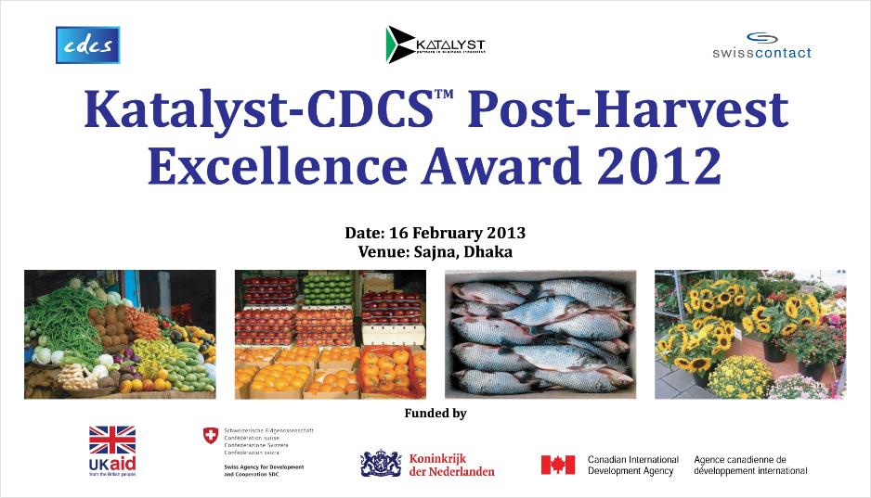
Under a CDCS®-Katalyst project on Packaging Market Development, CDCS® joined hands with eight distinguished partners and created 242 change ambassadors who conducted 3,190 farmer meetings in different formats. Through these change ambassadors CDCS® reached 60,793 farmers, including 26,987 women and 3,189 lead farmers. All of CDCS® change ambassadors have done very well and put great effort in carrying out their job. CDCS® together with relevant partner organizations has selected the best performing change agent from each of these organizations for Katalyst-CDCS® Postharvest Excellence Award 2012.
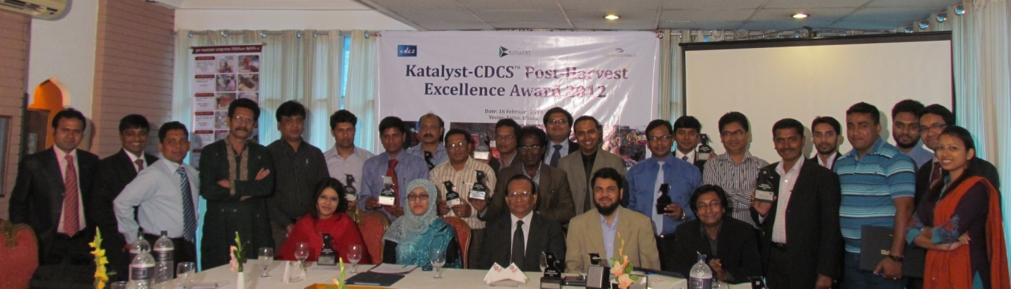
CDCS®-GPP7 has become a popular jargon not only at fields, but also beyond the boundary. Now CDCS® GPP7 is in poetry, it has won the poetic hearts…seeing the benefit, change ambassadors are getting inspired to write poems on it. Besides, CDCS® partnership model and its core GPP7 helped Novartis Bangladesh win Global Best practice Award in the Global Aqua Conference held in Chile in early this month.

