CDCS®-Novartis Partnership Wins Global Best Practice Award

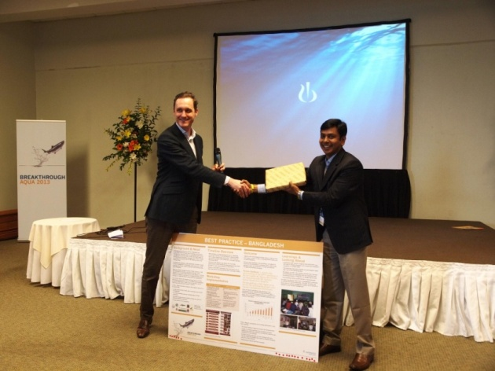
CDCS® and Novartis have jointly been working on farmer and value chain actor benefit enhancement since 2011. Under the collaboration, Novartis has been educating their beneficiaries and customers about seven CDCS® generated good postharvest practices (CDCS-GPP7).
On February 2013, Novartis presented the CDCS® Market Development Model at its Global Aqua Conference held in Chile. The conference was represented by 35 different countries from Europe, USA and Asia Novartis-CDCS® Partnership won Global Best Practice Award, bagging 19 out of 35 votes.

